**C:\Users\linesra\AppData\Local\Microsoft\Windows\Temporary Internet Files\Content.IE5\C9MXBSQH\MC900351955[1].wmf7th Grade Science**

**2018-2019**

This year is going to be an exciting year! In 7th Grade Science we are going to be covering:

* Energy, Forces and Interaction
  + 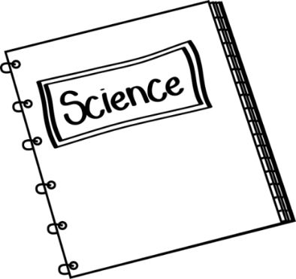September to October
* Solar System
  + November to December
* Life on Earth
  + January to March
* Environmental Science
  + March to May
* Science Inquiry
  + On-going all year
* Writing and Reading in Science
  + On-going all year

In learning these topics we will discover new information from exploratory activities, inquiry based activities, hands-on laboratory, and integrating technology. These topics cover a multitude of information and it is very key in the middle school level to be on top of the work and not fall behind. If you need help, please let your teacher know!

This year the 7th grade science classes will focus heavy on technology integration and art integration. Technology integration is integrating as much technology into our classroom lessons and daily tasks as possible. These are awesome opportunities for the students to show that they understand the material in a non-traditional way.

Homework is not traditionally assigned but due to having technology integration extra practice could always be done at home if the student has access to the internet. If you ever need to know your student login information to either the website that have the lessons or the “testing” website please let your teacher know!

During the first, two week of school students will come up with a *social contract* in our class. Students will have input on how they will be able to demonstrate how to be **collaborative, professional,** and **respectful** in our class. A list will be made and each student will be expected to follow the contract. With this contract, basic science safety expectations will be addressed.

At Harding, our students are viewed as scholars (**#scholarsfirst**). We expect that students understand the responsibility that comes with being a scholar and make it to class on time. To help students be successful at this we have the **Rule of 3** in place.

1. ****First tardy = a warning.
2. Second tardy = contact home.
3. Third tardy and beyond = the student and teacher will schedule a **Give ‘em Five** time to work on a solution to make sure the student is successful in being on time to class. Each tardy beyond, the student will make up the time with a teacher.

The Rule of 3 are used and will become more familiar as the school year goes on.

In science, **standards based grading** will be in effect. This means that there is no way you should not have an A, if you work for it! Each standard will be graded individually and you will be given *multiple* attempts at a standard. Each standard will be either master, proficient, learning, or a not yet. Each student will receive multiple attempts for each standard in the classroom but if an individual needs more attempts, they may schedule a time with the teacher to take another attempt. An attempt may be in written form, quiz form, verbal form, or in a demonstration.

Scales will be specific to the unit. Here is a generic outline of what a scale looks like:

|  |  |
| --- | --- |
| Score 0 | No effort; didn’t turn in attempt |
| Score 1 | Far to go to reach proficiency |
| Score 2 | On track to meet proficiency |
| Score 3 | Proficient |
| Score 4 | Above and beyond as well meeting all proficiency standards. |

If you would like to see the scales for the unit that your student is working on, do not hesitate to ask your teacher, or student, to see the scales.

Please do not hesitate to ask any questions regarding this syllabus, the class, or myself.

**Scott Schyvinck Madison Hutchins Owen Hernandez**

**Room 242 Room 246 Room 146**

[Scott.Schyvinck@dmschools.org](mailto:Scott.Schyvinck@dmschools.org) [Madison.Hutchins@dmschools.org](mailto:Madison.Hutchins@dmschools.org) [Owen.Hernandez@dmschools.org](mailto:Owen.Hernandez@dmschools.org)